SCEP communication flow overview
The following image demonstrates a basic overview of the SCEP communication process in Intune. Each step includes a link to an article with more prescriptive guidance.
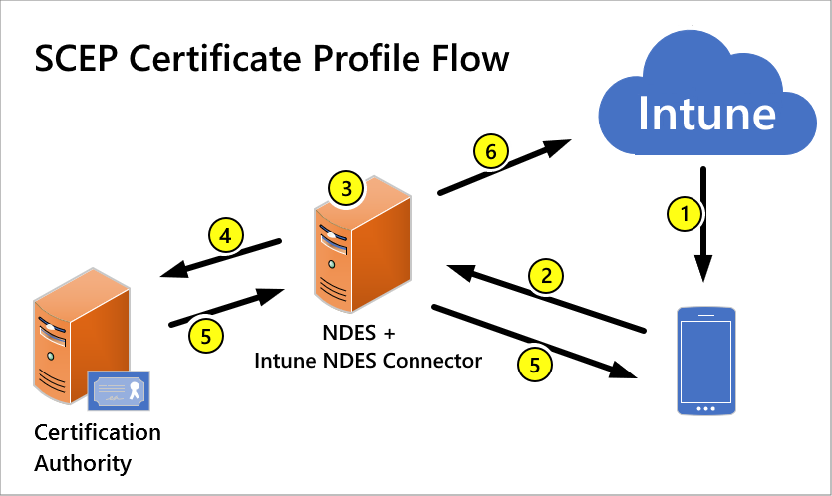
- Deploy a SCEP certificate profile. Intune generates a challenge string, which requires a specific user, certificate purpose, and certificate type.
- Device to NDES server communication. The device uses the URI for NDES from the profile to contact the NDES server so it can present a challenge.
- NDES to policy module communication. NDES forwards the challenge to the Intune Certificate Connector policy module on the server, which validates the request.
- NDES to certification authority. NDES passes valid requests to issue a certificate to the Certification Authority (CA).
- Certificate delivery to the device. The certificate is delivered to the device.
- Reporting of deployment to Intune. The Intune Certificate Connector reports the certificate issuance event to Intune.

